Lab 2 Write Up

Alex Horton
SWE 2410 121: Design and Cloud Patterns
Dr. Adela Velez
January 29, 2026

UML Diagram
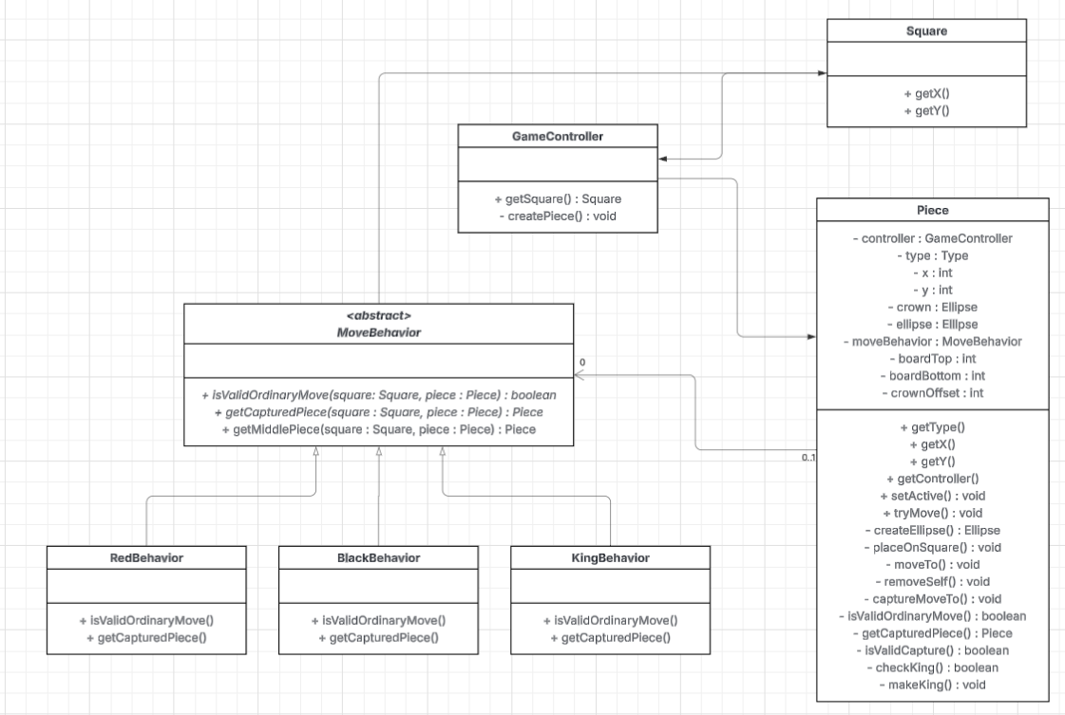
Questions
I implemented the strategy pattern in this lab by creating separate classes for the movement behavior of red, black, and king pieces. I used an abstract class for move behavior to avoid duplicating the getMiddlePiece method across multiple classes. Using an interface is possible but having getMiddlePiece in one place makes the code more maintainable as you don’t have to modify getMiddlePiece in each subclass if it is modified. I chose to pass a reference to the piece when isValidOrdinaryMove and getCapturedPiece are called because the movement behavior is set in the constructor instead of using a setter. If you were using a setter it would still make sense to use an abstract class because each MoveBehavior object could contain a reference to a piece instead of having to pass one each time.
I modified the Piece class in a few areas. To facilitate the strategy pattern I added getX and getY methods so that the behavior classes could access the piece’s position. I also added a new instance variable called moveBehavior to hold a MoveBehavior object and removed the king boolean as it is not necessary with the new movement implementation. I modified the isValidOrdinaryMove and getCapturedPiece methods to call methods from moveBehavior instead of using conditionals. I also modified the makeKing function to set moveBehavior to KingBehavior instead of setting the now removed king variable.
The strategy pattern fits this problem well. Implementing it requires some extra methods to be added as well as a few other modifications that add complexity to the refactoring. Even though there is initial complexity implementing new movement types is much easier than before. Adding the getX and getY methods as well as making getMiddlePiece not private may be seen as undesirable because it exposes parts of the program you might not want others to be able to use.

